🍕 Pizza Sales Analysis Queries

**A) KPIs (Key Performance Indicators)**

1. Total Revenue

select sum(total_price) as total_revenue from pizza_sales

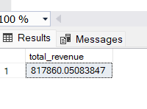

2. Average Order Value

select sum(total_price) / count(distinct order_id) as avg_order_value from pizza_sales

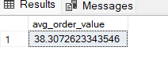

3. Total pizzas sold

select sum(quantity) as total_pizza_sold from pizza_sales

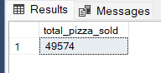

4. Total count of orders placed

select count(distinct order_id) as total_orders from pizza_sales

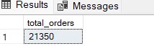

5. Average pizza per order

select cast(cast(sum(quantity) as decimal (10,2)) /

cast(count(distinct order_id) as decimal (10,2)) as decimal (10,2)) as avg_pizzas_per_order from pizza_sales

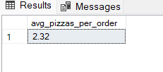

**B) Daily trends for order placed**

select DATENAME(DW, order_date) as order_day, COUNT(distinct order_id) as total_orders

from pizza_sales

group by DATENAME(DW, order_date)

order by total_orders desc

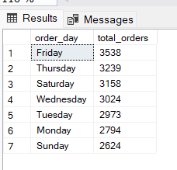

**C) Monthly order for trends**

select DATENAME(MONTH, order_date) as month_name, COUNT(distinct order_id) as total_orders

from pizza_sales

group by DATENAME(MONTH, order_date)

order by total_orders desc

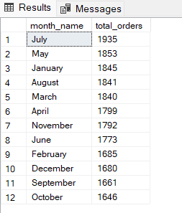

**D) % of sales by pizza category**

select pizza_category, CAST(SUM(total_price) as decimal(10,2)) as total_sales, CAST(SUM(total_price) * 100 /

(select SUM(total_price) from pizza_sales) as decimal(10,2)) as perc_of_sales

from pizza_sales

group by pizza_category

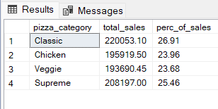

**E) % of sales by pizza size**

select pizza_size, CAST(SUM(total_price) as decimal(10,2)) as total_sales, CAST(SUM(total_price) * 100 /

(select SUM(total_price) from pizza_sales) as decimal(10,2)) as perc_of_sales

from pizza_sales

group by pizza_size

order by pizza_size

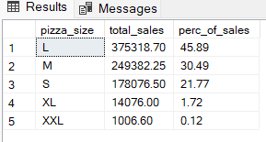

**F) Total Pizzas sold by Category**

select pizza_category, SUM(quantity) as total_quantity_sold from pizza_sales

group by pizza_category

order by total_quantity_sold desc

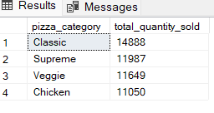

**G) Top 5 best sellers by revenue**

select top 5 pizza_name, SUM(total_price) as total_revenue from pizza_sales

group by pizza_name

order by total_revenue desc

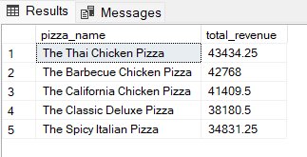

**H) Bottom 5 best sellers by revenue**

select top 5 pizza_name, SUM(total_price) as total_revenue from pizza_sales

group by pizza_name

order by total_revenue

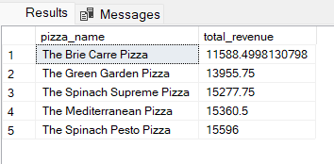

**I) Top 5 best sellers by quantity**

select top 5 pizza_name, SUM(quantity) as total_quantity from pizza_sales

group by pizza_name

order by total_quantity desc

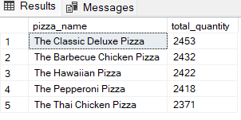

**J) Bottom 5 best sellers by quantity**

select top 5 pizza_name, SUM(quantity) as total_quantity from pizza_sales

group by pizza_name

order by total_quantity

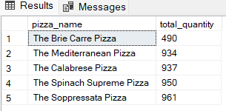

**K) Top 5 best sellers by total orders**

select top 5 pizza_name, SUM(distinct order_id) as total_orders from pizza_sales

group by pizza_name

order by total_orders desc

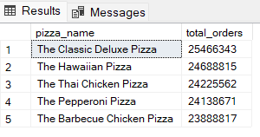

**L) Bottom 5 best sellers by total orders**

select top 5 pizza_name, SUM(distinct order_id) as total_orders from pizza_sales

group by pizza_name

order by total_orders

